AI-Based Patent and Research Gap Discovery Using RAG and Multi-Agent AI

Alvira Parveen
Department of Computer Science & Engineering
Sharda University
Greater Noida
alviraparveen27@gmail.com
Rohit
Department of Computer Science & Engineering
Sharda University
Greater Noida
ranuranu2006@gmail.com
Dr. Sandeep Gupta
Department of Computer Science & Engineering
Sharda University
Greater Noida
guptasandeep1093@gmail.com

Abstract—Identifying prior art and spotting potential research gaps for new inventions is a time-consuming task. This is because technical information is scattered across patent documents and scientific papers. This paper introduces a retrieval-augmented multi-agent system designed to help with early-stage invention screening and discovering research gaps across both patent and research-literature sources.The system starts with a natural-language invention idea. It then searches for content by using Sentence-Transformer embeddings, FAISS-based dense retrieval and BM25-based hybrid ranking to find relevant passages from patents and research papers. A modular LangGraph workflow manages agents. These agents handle tasks like patent analysis, scientific literature review, technical feature comparison prior-art overlap detection and identifying research gaps.To make the process more transparent the system includes a report-generation step. This step uses source chunk identifiers, document metadata and exact excerpts from the text. This allows users to verify claims by tracing them to the original passages they were based on.The framework was tested on a selected set of 40 documents, 20 patents and 20 research papers along with 20 technical queries. Hybrid retrieval achieved a Precision@3 of 46.67% while dense- retrieval scored 36.67%. However the improvement was not statistically significant after adjusting for comparisons.An interactive prototype built with Streamlit demonstrates the workflow, including the ability to inspect the source passages that support each finding. The framework enables evidence-based exploration of prior art and potential research gaps. It’s important to note that the overlap scores are engineering heuristics, not evaluations of patentability. More independent testing is needed to confirm how accurate the system is, in identifying citations and how well it works across different domains.
Keywords—Patent analysis, research-gap discovery, retrieval-augmented generation, multi-agent systems, hybrid information retrieval, evidence grounding, explainable artificial intelligence.
- Introduction
The rising number of technical disclosures in patent databases and scientific literature has made initial invention screening an arduous job [1]–[4]. It is required from researchers to sift through disparate documents, analyze specialized documents and verify already existing implementations in order to find prior arts and gaps in research.
A major challenge is the dissimilarity of the patent specifications which describe the scope of legal claims and what has been disclosed, and the scientific publications that focus on the research progress, experimental results, and limitations [5], [14], [21], [34]. Existing discovery workflows often examine these sources separately. Although retrieval-augmented generation (RAG) and large language models (LLMs) can assist technical analysis [6], [8], [28], [32], conventional pipelines may combine heterogeneous evidence without sufficient domain separation or source-level traceability, increasing the risk of unsupported claims. To address these challenges, this paper presents a retrieval-augmented multi-agent framework for preliminary prior-art screening and exploratory research-gap discovery across patent and academic corpora. The framework combines dense and lexical retrieval, specialized analysis agents coordinated through LangGraph, feature-level comparison, and passage-anchored report generation. Its main contributions are:
- Dual-Corpus Hybrid Retrieval: An information retrieval pipeline combining Sentence-Transformer embeddings (all-MiniLM-L6-v2), FAISS dense vector search, and BM25 lexical ranking to concurrently retrieve and rank candidate evidence from partitioned patent and academic literature corpora.
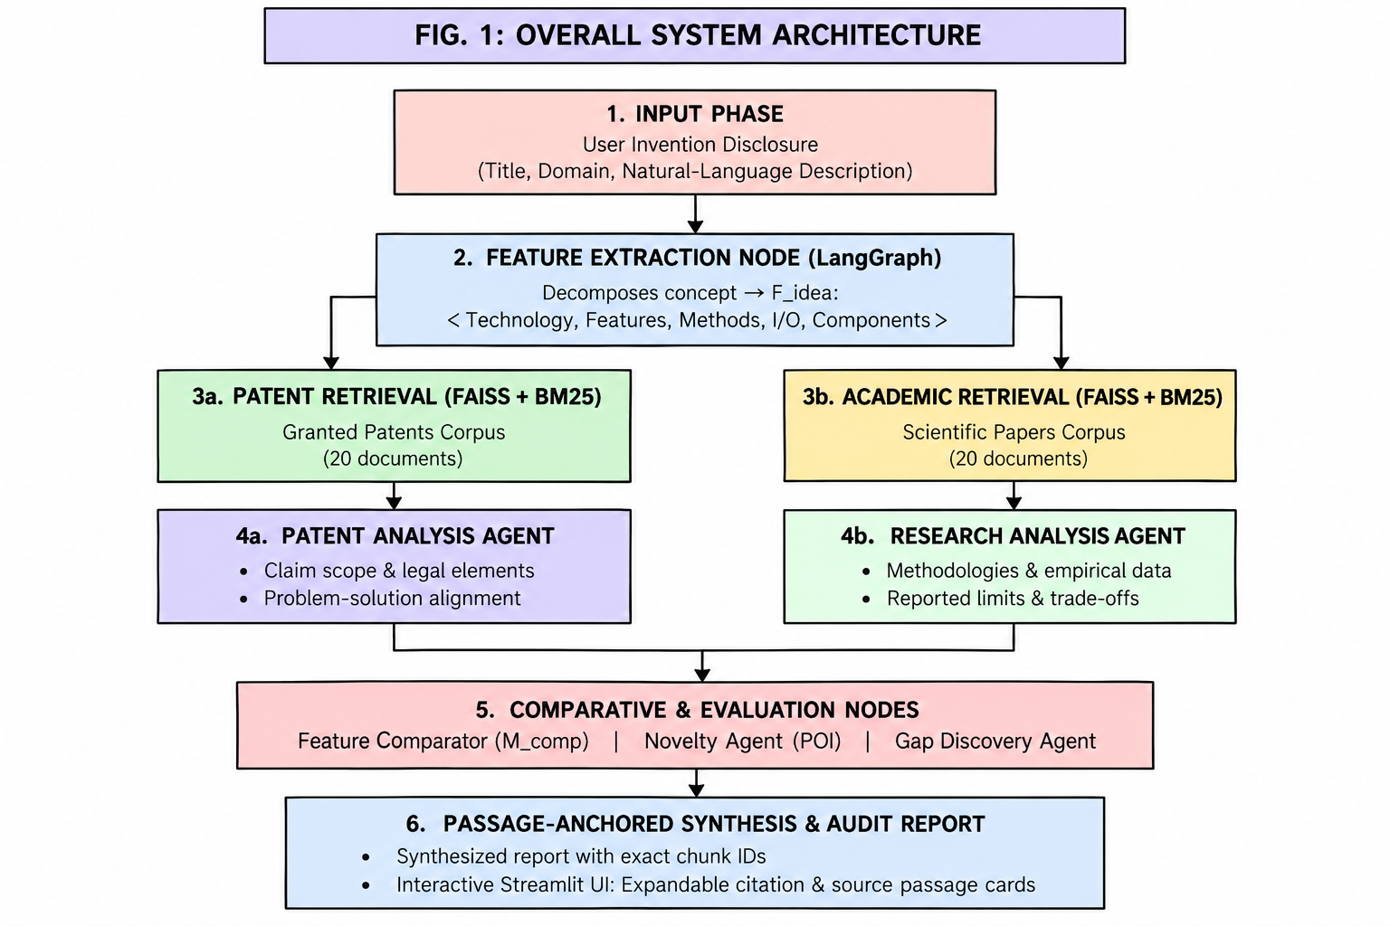
- Modular Multi-Agent Architecture: a graph-driven system designed within LangGraph and which separates the previous works analysis task through the use of distinct agents, that is, the Patent Analysis Agent, which studies the structure of the claims. the Research Analysis Agent, which identifies the innovative methods. the Feature Comparison Agent, which creates alignment matrices, and the Gap Detection Agent which finds the gaps that can be filled with available literature.
Fig. 1. Overall architecture of the proposed dual-corpus, multi-agent research-gap discovery framework.
- Synthesis and Traceability through the Example of the Online Synopsis Generation method: refers to the process of synthesis where source text segments, their sources and their snippets act as inputs reducing unsupported assertions.
- Empirical Testing and Prototype Launch: the quantitative testing standard based on 40 documents (20 patents and 20 academic articles) addressed with 20 queries; the test outputs the metrics for the dense/hybrid retrieval benchmarks and the interactive demonstration model created in Streamlit.
- Related Work
Recent research papers addressing patent analysis and AI ideation are summarised in Table I [1]–[20], while relevant patents covering retrieval and claim mapping are analyzed in Table II [21]–[40].

Table I — Comparative Analysis of 20 Selected Research Papers
No. | Title & Year | Authors | Method / Key Finding / Limitation
[1] | Patent Intelligence in the Age of AI: Unlocking Strategic Insights through Granular Classification [2026] | Giuntelli et al. | LLM + RAG; patent intelligence; hallucination/cost
[2] | Agent Ideate: A Framework for Product Idea Generation from Patents Using Agentic AI [2025] | Kanumolu et al. | Multi-agent AI; patent ideation; domain dependent
[3] | Many Heads Are Better Than One: Improved Scientific Idea Generation by a LLM Based Multi Agent System [2026] | Dong et al. | Multi-agent LLM; scientific ideation; no patent analysis
[4] | EVOPAT: A MULTI-LLM-BASED PATENTS SUMMARIZATION AND ANALYSIS AGENT [2024] | Wang et al. | Multi-LLM + RAG; patent analysis; patent focused
[5] | Can AI Examine Novelty of Patents?: Novelty Evaluation Based on the Correspondence between Patent Claim and Prior Art [2025] | Ikoma et al. | LLM + claim matching; novelty evaluation; domain/year dependent
[6] | In-depth Analysis of Graph-based RAG in a Unified Framework [2026] | Zhou et al. | GraphRAG; improved retrieval; model/context limitations
[7] | Exploring Design of Multi-Agent LLM Dialogues for Research Ideation [2025] | Ueda et al. | Multi-agent dialogue; idea refinement; no novelty verification
[8] | An automatic patent literature retrieval system based on LLM-RAG [2025] | Ding et al. | FAISS + RAG; patent retrieval; no gap analysis
[9] | Research on Evaluation Methods for Patent Novelty Search Systems and Empirical Analysis [2025] | Zhang et al. | Semantic search; novelty-search evaluation; incomplete ground truth
[10] | ToC: Tree-of-Claims Search with Multi-Agent Language Models [2026] | Yu et al. | Multi-agent + MCTS; claim search; domain specific
[11] | IdeaForge: A Knowledge Graph-Grounded Multi-Agent Framework for Cross-Methodology Innovation Analysis and Patent Claim Generation [2026] | Bose | KG + multi-agent; innovation analysis; small use-case set
[12] | AgentSwift: Efficient LLM Agent Design via Value-Guided Hierarchical Search [2026] | Li et al. | Hierarchical agent search; efficient agents; not patent-gap focused
[13] | TCLMA: A Two-dimension Contrastive Learning based Multiagent Framework for Scientific Novelty Evaluation [2025] | Zheng et al. | Contrastive learning + agents; novelty evaluation; no white-space analysis
[14] | Integrated Patent Prior Art Search with Claim Aware Retrieval and Novelty Assessment [2026] | Han et al. | Claim-aware retrieval; prior-art + novelty; no research-gap analysis
[15] | A novel patentability detection model based on Siamese network [2025] | Kayaköku et al. | Siamese LSTM; patentability detection; EV domain only
[16] | Towards Automated Patent Workflows: AI-Orchestrated Multi-Agent Framework for Intellectual Property Management and Analysis [2024] | Sakhinana Sagar Srinivas et al. | Agents + RAG + KG; automated IP workflow; USPTO focused
[17] | Enhancing the Patent Matching Capability of Large Language Models via the Memory Graph [2025] | Xiong et al. | Memory Graph + RAG; patent matching; no gap discovery
[18] | AI-based novelty detection in crowdsourced idea spaces [2024] | Just et al. | SBERT + similarity; idea novelty detection; moderate human correlation
[19] | An extraction and novelty evaluation framework for technology knowledge elements of patents [2024] | Wei et al. | BERT + UIE + KG; technology-element novelty; domain specific
[20] | Retrieval-Augmented Generation Systems for Intellectual Property via Synthetic Multi-Angle Fine-tuning [2025] | Ren et al. | RAG + retriever tuning; IP retrieval; Taiwan focused

Table II — Comparative Analysis of 20 Selected Patents
No. | Patent & Year | Technology / Method | Key Capability / Limitation
[21] | Patent Claim Reference Generation [2020] | Claim-limitation extraction + evidence retrieval | Claim evidence generation; claim-focused
[22] | Vector-Based Contextual Text Searching [2022] | Vector representations + similarity ranking | Semantic text retrieval; general-purpose
[23] | Novelty Detection Using Deep Learning Network [2022] | Autoencoder + representation comparison | Novelty scoring; not patent-specific
[24] | Automated System and Methodology for Feature Extraction [2022] | ML-based feature extraction | Automated feature extraction; domain-specific
[25] | Construction Method, Device, Computing Device, and Storage Medium for Constructing Patent Knowledge Database [2023] | BERT/NER + knowledge graph | Patent knowledge extraction; KG construction
[26] | Machine Learning Architecture for Contextual Data Retrieval [2023] | Query generation + contextual retrieval | Retrieval and confidence checking; general-purpose
[27] | Automated Patent Claim Scope Concept Mapping [2023] | Semantic claim analysis + concept mapping | Claim scope mapping; patent-focused
[28] | Personalized Retrieval-Augmented Generation System [2023] | Embeddings + vector DB + LLM | RAG-based retrieval; personalized focus
[29] | Platform for Semantic Search and Dynamic Reclassification [2024] | Semantic search + graph analysis | Patent/scientific document search; broad platform
[30] | Digital Information Infrastructure and Method for Security Designated Data and with Granular Data Stores [2017] | Distributed storage + granular extraction | Structured data management; not patent-gap focused
[31] | Retrieval-Augmented Generation (RAG) System Optimization [2025] | Chunking + vector retrieval + ranking | RAG optimization; retrieval-focused
[32] | Method and System for Optimizing Use of Retrieval-Augmented Generation Pipelines in Generative AI Applications [2025] | Multi-LLM + RAG orchestration | Specialized RAG pipelines; architectural reference
[33] | Methods and Systems of Handling Patent Claims [2017] | Claim parsing + semantic processing | Patent claim handling; claim-focused
[34] | Systems and Methods for Analyzing Validity or Infringement of Patent Claims [2020] | NLP + information retrieval | Claim evidence matching; legal analysis
[35] | Artificial Intelligence, Machine Learning, and Predictive Analytics for Patent and Non-Patent Documents [2022] | ML + predictive analytics | Patent/non-patent document analysis; legal/predictive focus
[36] | Enhanced Search Result Generation Using Multi-Document Summarization [2024] | Multi-document RAG + summarization | Cross-document synthesis; no research-gap analysis
[37] | Multi-Segment Text Search Using Machine Learning Model for Text Similarity [2025] | ML-based segmented-text similarity | Patent reference retrieval; similarity-focused
[38] | Patent Mapping [2025] | Claims + concepts + ontologies | White-space and technology mapping; patent-centric
[39] | Computer Implemented Methods for Automated Analysis/Use of Data, Including LLM [2026] | LLM + structured semantic reasoning | Search augmentation and reasoning; general-purpose
[40] | Augmented Question and Answer with Large Language Models [2026] | Embeddings + nearest-segment retrieval + LLM | Contextual document QA; no gap discovery

- PROPOSED METHODOLOGY
The components of the architecture, the algorithms for retrieval, the multi-agent coordination protocol, and the means of grounding the evidence in the framework presented in this paper are all covered in detail in this section.
- Overall System Architecture
The proposed framework integrates patent retrieval, scientific literature analysis, multi-agent reasoning, and evidence-grounded report generation into a unified workflow. Coordinated through LangGraph, the system extracts technical features from an invention concept [24], retrieves relevant passages from separate patent and research-paper [22], [26] corpora, and analyses the retrieved evidence to compare technical features, assess prior-art overlap, and identify potential research gaps.
The workflow maintains a shared state, represented by
$[S=⟨I,Fidea,Rpat,Rpap,Apat,Apap,Mcomp,N,G,T_{rep}⟩,]$
where $(I)$denotes the input invention concept; $(F$$idea)$ represents its extracted technical features; $(Rpat)$ and $(Rpap)$denote retrieved patent and research-paper passages, respectively; $(Apat)$ and $(Apap)$ contain their corresponding analyses; $(Mcomp)$ denotes the feature-comparison matrix; $(N)$ represents the preliminary prior-art overlap assessment; $(G)$contains candidate research gaps; and $(T_{rep})$ denotes the generated report.
The system consists of four stages - (i) obtaining technical features from the source idea; (ii) obtaining information from the sources concerning the patent literature and scientific literature; (iii) engaging the experts to study the data relating to the features under observation, measure the degree of similarity, and find the ways to get the research gap started; and (iv) collecting all information in the attainments of the past paper.
The methods mentioned above have been implemented in Python 3.11 code, LangGraph is responsible for workflow management, Pydantic v2 is responsible for quality of the language used, Streamlit is responsible for accessing the program by the users. The language-model features include the work with Google Gemini 2.5 system and built-in fallback.
- Dual-Corpus Hybrid Retrieval
The terminology used in patent specifications is formal legal language, while scientific articles use discipline-specific language. Dense retrieval identifies words similar in meaning but may miss out on relevant keywords and classification codes, whereas lexical retrieval identifies precise terms but ignores similar meanings. The proposed framework combines both approaches across separate patent and scientific literature corpora.
For a query (q) and document chunk (c), dense retrieval represents each as a 384-dimensional embedding and calculates cosine similarity:
$S_{dense}(q,c)=\frac{e_{q}⋅e_{c}}{∥e_{q}∥∥e_{c}∥}----(i)$
In parallel, Lexical relevance is calculated using BM25:
$S_{lex}(q,c)=BM25(q,c)---(ii)$
The two ranked lists are combined using Reciprocal Rank Fusion (RRF):
$RRF(c)=\frac{1}{k+r_{dense}(c)}+\frac{1}{k+r_{lex}(c)}---(iii)$
Here, $r_{dense}(c)$ and $r_{lex}(c)$ denote the rank of chunk $c$ in the dense and lexical result lists, respectively, and $k=60$ is the RRF smoothing constant. The top $K=5$ chunks from each corpus are retained to populate the patent and paper retrieval results, denoted by $R_{pat}\text{and}R_{pap}$.
Text is extracted from digital PDF files using PyMuPDF, while Tesseract OCR is used for scanned documents. The extracted text is divided into chunks of $L=600$ tokens with an overlap of $Δ=80$ tokens. Dense embeddings are generated using Sentence-Transformers with the all-MiniLM-L6-v2 model and stored in L2-normalized FAISS indices [22]. Lexical retrieval is implemented using rank_bm25.

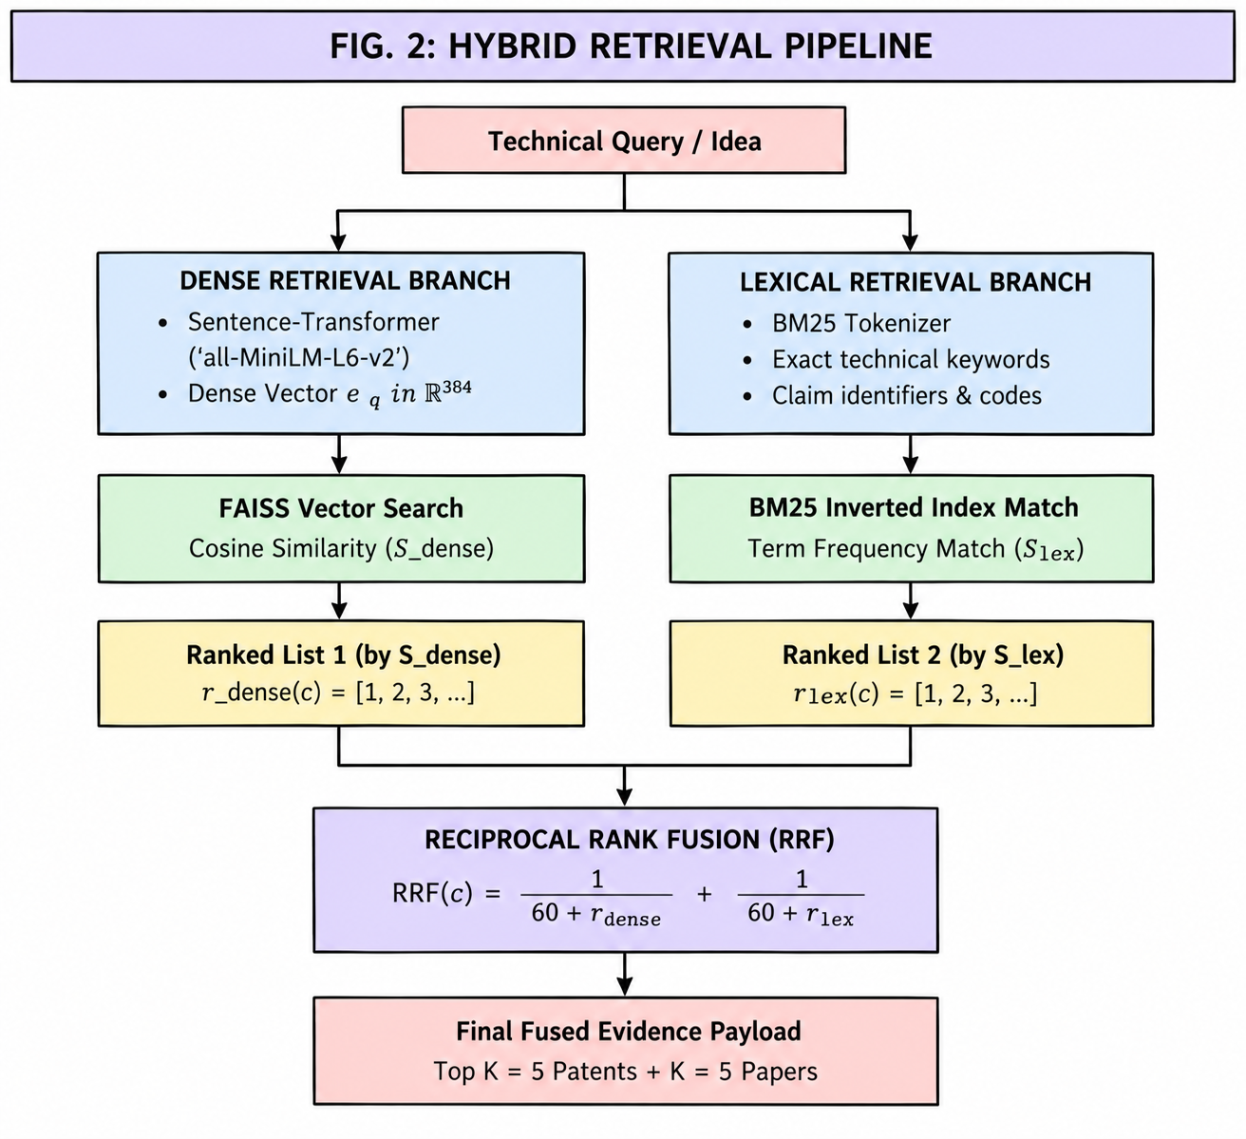
- Multi-Agent Orchestration
The framework uses LangGraph to coordinate specialized agents for patent analysis, scientific literature analysis, feature comparison, prior-art overlap assessment, and research-gap identification. The PatentAnalysisAgent extracts claim scope and disclosed technical implementations [13], [33], while the ResearchAnalysisAgent identifies research methodologies, empirical findings, and documented limitations [3], [7]. The FeatureComparator is responsible for comparing their results and categorizing the technical features as either Match, Partial Match, or Uncovered.
Fig. 2. Dual-Corpus Hybrid Retrieval Pipeline Using Dense and Lexical Search with Reciprocal Rank Fusion.
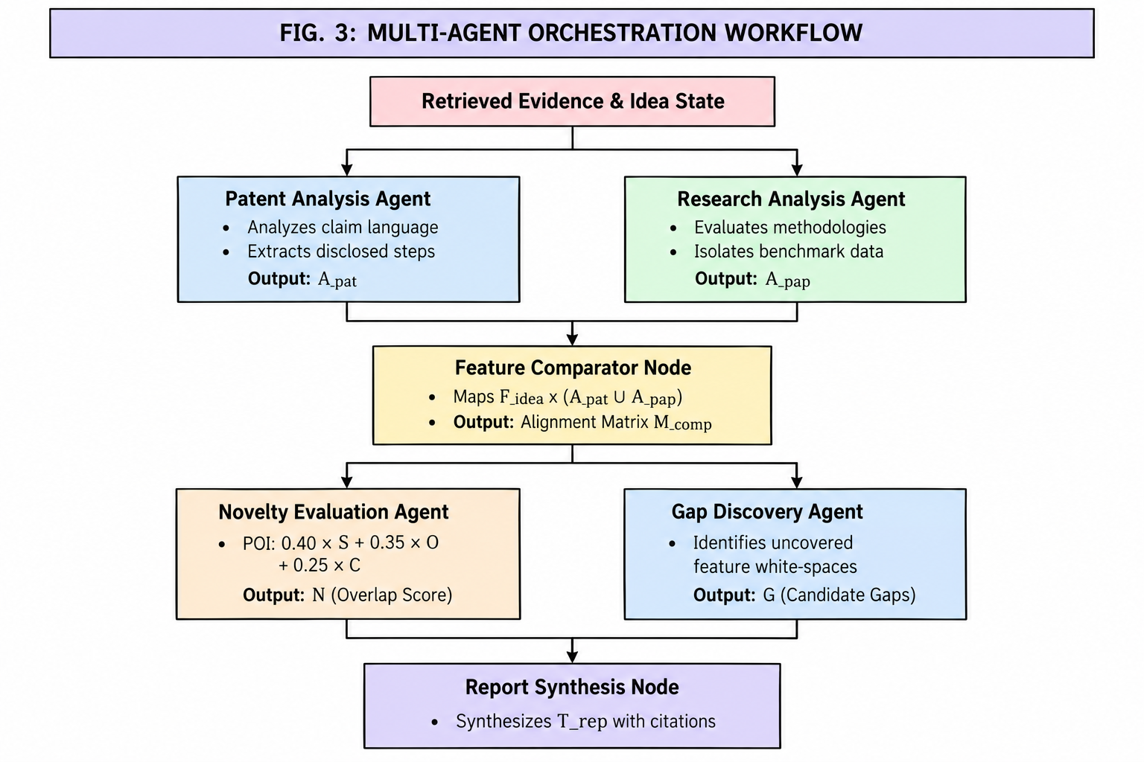
- The NoveltyAgent calculates a preliminary Prior-Art Overlap Index (POI) using semantic similarity $((S_{sem}))$, technical feature overlap $((O_{tech}))$, and patent claim coverage $((C_{claim}))$ [5], [9], [15], [23] :
$POI=0.40S_{sem}+0.35O_{tech}+0.25C_{claim}---(iv)$
An evidence-adjusted engineering overlap score is then calculated as:
$OverlapScore=1.0-\left[POI(0.60+0.40E_{str})\right]---(v)$
where $(E_{str})$represents evidence strength. The scores discussed herein are meant for an initial scan and have no bearing on patent novelty or the suitability of getting a patent in the legal sense. The GapDiscoveryAgent finds out undiscovered features and opportunities for cross-domain research based on the collected data.
All of the agents in the process transfer structured updates based on information confirmed by Pydantic frameworks with LangGraph controlling the work process. The last synthesis node takes the outputs of the agents and pieces of the sources together.
Fig. 3. Multi-Agent Orchestration Workflow for Patent Analysis, Literature Analysis, and Research-Gap Discovery
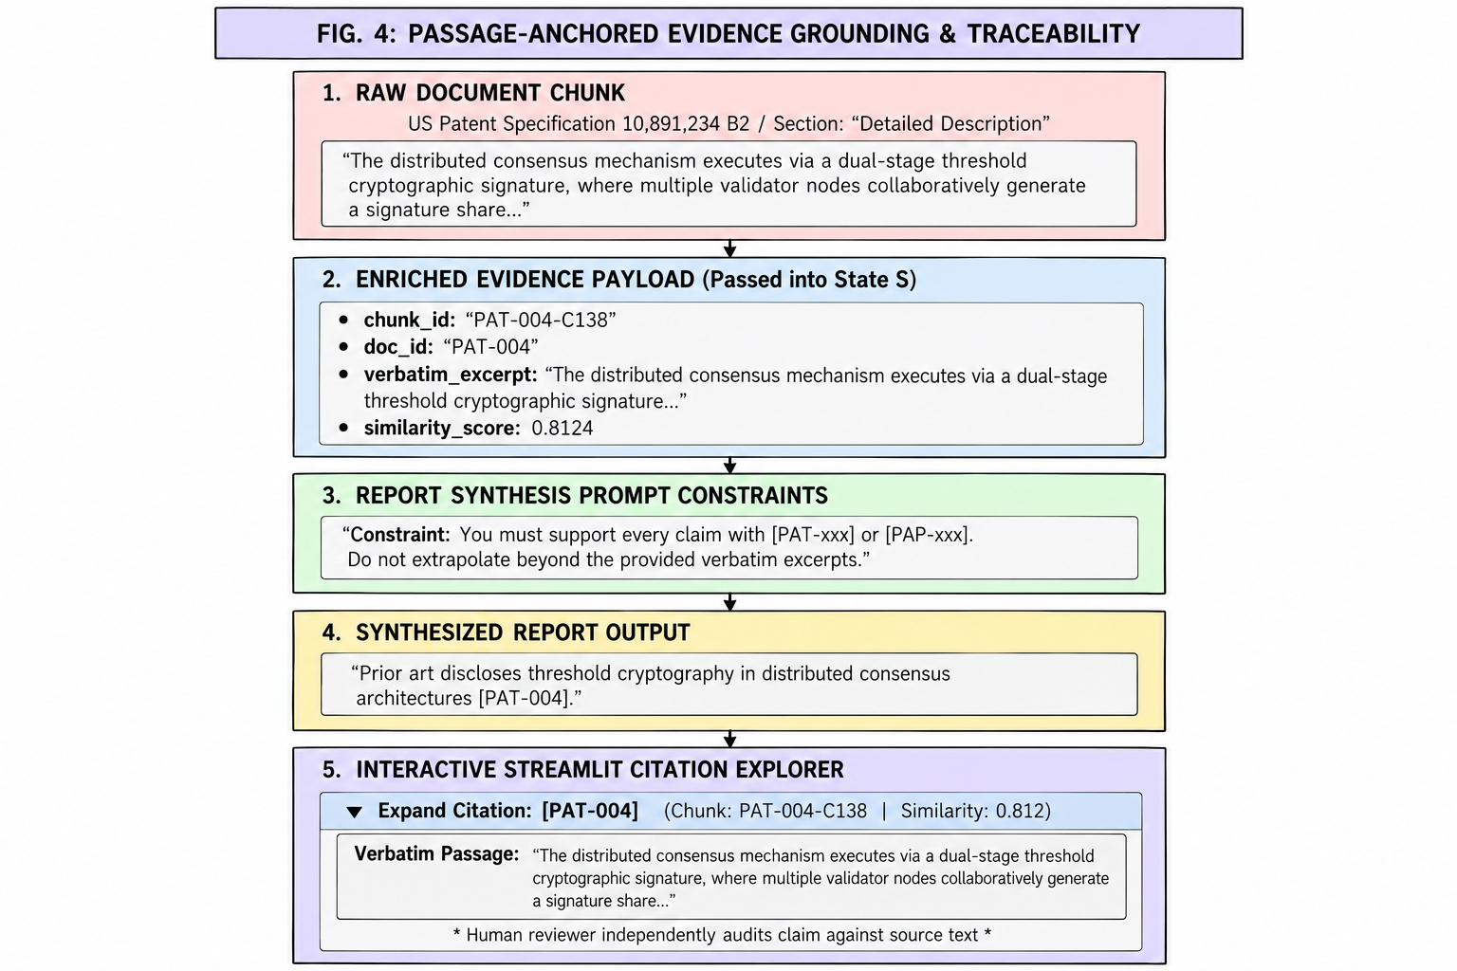
- Passage-Anchored Evidence Grounding
In order to enhance traceability and limit unsupported claims, the framework grounds report synthesis results in sourced text snippets. The synthesis node obtains canonical document IDs (for instance, PAT-004), chunk IDs (for instance, PAT-004-C138), verbatim quote texts of 200 to 800 characters and section metadata. The prompt also tells the model to reference the relevant chunk IDs and base its technical description on given evidence.
The final report contains citations along with an interactive Citation and Source Passage Inspector in Streamlit, which enables the user to review metadata about the document, as well as the similarity level and snippets from the source. This allows the findings obtained to be validated by a human against the evidence that has been retrieved.
Fig. 4. Passage-Anchored Evidence Grounding and Citation Traceability in Report Generation.
- SYSTEM IMPLEMENTATION
This section will describe the software stack, document processing, agent execution, large language model back-end, user interface, and verification procedures used in the prototype.
- Software Stack and Execution Environment
This prototype is implemented using Python 3.11 and tested in Apple Silicon and Linux x86_64 environments. For agent orchestration, LangGraph is utilized and structured data is validated using Pydantic v2. In the case of dense retrieval, Sentence-Transformers (all-MiniLM-L6-v2) and dedicated FAISS indices from both patent and research paper categories are used. For lexical retrieval, rank_bm25 with custom tokenization is employed. The PDF extraction is carried out using PyMuPDF along with Tesseract OCR, while Streamlit provides the visual, interactive interface.
- Ingestion, Chunking, and State Management
In testing its functionalities, the prototype uses a collection of 40 documents, of which 20 are patent descriptions and 20 academic articles. The documents get split into semantically aware sections of 600 tokens with an overlap of 80 tokens which gets deduplicated with the aid of MD5 hashing.
LangGraph implements a typed AgentState used by all nodes in their processing. The system streamlines various operations, namely, feature extraction, patent investigation, research analysis, comparing features, measuring overlap, identifying gaps, and producing reports. Each node in this setup works on its task and provides state updates.
- Dual-Engine LLM Backend and Fallback
Google Gemini 2.5 Flash functionality is provided by the prototype through an OpenAI-compliant API endpoint. The sampling temperature is kept at T=0.2 to lower variability in the responses. If incurring issues due to API rate limits or interruptions in the network connection prevent the online generation from occurring, offline generation will create structured reports using relevant technical terms present in retrieved passages and their corresponding chunk IDs. This way, the invention is less reliant on the availability of APIs in the demonstration and testing processes.
- Interactive Streamlit Interface and Citation Explorer
One of the functionalities of Streamlit is allowing users to submit their ideas for inventions, make benchmark inquiries, check the progress of execution, view feature comparison tables, and visualize preliminary overlap analysis and research gaps. Users can access citation explorer to obtain cited chunk indexes, fetching scores, metadata of the document, and the text of documents. It is possible to export reports and related state information in JSON and Markdown form.
- Verification and Test Suite
The system was assessed with the use of 34 pytest cases that automated the testing of graph transitions, chunk boundaries, reciprocal rank fusion, schema validation, and fallback behavior. All of the tests were successful with only one warning. An end-to-end check was established which checked six different criteria. A key check was whether the chunk identifiers cited resolved back to the original passages.
- RESULTS AND ANALYSIS
The framework was evaluated based on the retrieval performance, citation provenance, claim-support verification, and the distinctions made between assessments made under patent law and those made on research gap academic level.

Table III. Retrieval Performance Comparison on 20 Technical Queries
Metric | Dense-only | Hybrid-RRF
Precision@3 | 0.3667 | 0.4667
Precision@5 | 0.3200 | 0.3600
Recall@3 | 0.3242 | 0.3983
Recall@5 | 0.4675 | 0.5058
MRR | 0.7792 | 0.8208
- Dual-Corpus Retrieval Performance
The comparison between two retrieval methods: Dense-only and hybrid retrieval was performed using 20 technical questions on a collection of 40 documents. The findings show that hybrid-RRF outperformed each of the five metrics and precision@3 results improved from 0.3667 to 0.4667 while Mean Reciprocal Rank (MRR) increased from 0.7792 to 0.8208. However, none of the improvements was statistically significant after Holm correction $(adjusted(p≥0.9131))$.Even though these results demonstrate a successful tendency in retrieval, using a small set of documents does not show statistical significance in gaining a favorable outcome.
- Citation Provenance and Evidence Grounding
In a total of 20 benchmark cases evaluated, both standard RAG and multi-agent configuration successfully produced alleged factual statements whose associated chunk IDs matched with source documents in the corpus. In this regard, the origin of the candidate pool was clear to 100% for the standard configuration and 94.5% for the multi-agent configuration. The source of the discrepancies was six citations that pointed to sources that were already indexed but outside the candidate pool, although they did not belong to the retrieved candidate pool. The multi-agent configuration not only created as many as 40 candidate research gaps, while standard RAG produced only 20, but also demonstrated traceability and greater hypothesis production, without indicating correctness of semantics or novelty of research gaps.
- Claim-Support Verification
The first analysis of the 24-pair diagnostic dataset has shown that the two-stage hybrid evaluation has yielded accuracies of 79.2% and a macro F1 score of 0.7867 as opposed to a 75.0% accuracy score for the rule-based baseline and 54.2% for standalone NLI. The hybrid contradiction recall was 83.3%, which is equal to the results of the standalone NLI and much higher than the 33.3% recording of the rule-based baseline. However, one should note that since the diagnostic dataset is considered small, these results have a preliminary character..
- Patent and Academic Novelty Perspectives
The framework distinguishes patent law issues, which involve issues such as anticipation and obviousness, from issues in academic research that involve restrictions based on empirical research. The examples presented show that a combination can seem obvious to patent law but still raise an unresolved research problem. These examples serve to illustrate the separation between the two types of assessments but do not provide legal conclusions or reflect any consensus on the part of the reviewers.
- DISCUSSION
- Key Findings
The assessment indicates that hybrid retrieval, multi-agent analysis, and passage-level evidence grounding offer a systematic method for initial examination of prior-art search. Hybrid-RRF achieved an increase in Precision@3 from 0.3667 to 0.4667, even if the variance was not statistically significant later on after multiple-comparison corrections. All of the chunk IDs were resolved to corresponding source passages, which proves traceability but not semantic correctness as such. The multi-agent setup has produced more candidate research gap hypotheses than those in the standard RAG baseline. The conclusions are, nonetheless, preliminary, due to the modest size of evaluation datasets.
- Comparison with Existing Work
Patent searching systems are exclusively designed for patent-related searches. In contrast, academic search engines are focused entirely on academic publications and citations. The framework being developed merges both types of documents in one workflow that links identified information to comparing features, preliminary overlap assessment and finding gaps in research. The novelty of this approach lies in the ability to analyze the evidence at the passage level in both cases. Nevertheless, comparative performance analysis against the existing approaches has not yet been conducted in a controlled way.
- Advantages
The system provides a combination of semantic and lexical retrieval, specialized agents for analysis, structured comparison of features as well as citation tools. It uses a modular design for patent analysis as well as scientific literature analysis, where source identifiers and excerpts assist in understanding findings. The abovementioned possibilities enable transparent human-facilitated discovery of possible prior art and research possibilities.
- Limitations
This assessment relies on a small corpus of only 40 documents and 20 retrieval queries that restricts the generalization scope. Moreover, the fixed weights employed by the Prior-Art Overlap Index are engineering heuristics, not proven legal patentability metrics. The claim-support analysis comprises no more than 24 claim–passage combinations, while source-chunk resolution does not guarantee establishing semantic entailment. Document extraction and OCR can also generate errors. As a result, initially highlighted issues are limited to only an indexed corpus, with the prototype failing to deliver any legal patentability or freedom-to-operate assessments. The accomplishments here call for use of larger datasets, independent expert evaluations, and more extensive comparisons.
- CONCLUSION AND FUTURE WORK
- Conclusion
The overarching design presented in this article is a retrieval-enhanced multi-agent system for preliminary prior art search and the exploration of research gaps found in patent documents and academic publications. It employs hybrid retrieval methods based on Reciprocal Rank Fusion along with specialized analysis agents, comparison features, and passage-centric evidence mining. Testing on 40 documents and 20 technical queries revealed that hybrid retrieval improved Precision@3 from 36.67% to 46.67%, although the enhancement was not deemed statistically significant after the correction for multiple testing was applied. The prototype is capable of supporting source passage analysis and structured research gap generation in addition to that. The findings show the usability of auditable and limited discovery workflow.
- Future Work
Future tasks will consist of broadening the corpus and utilizing larger remark sets and independent human assessments to test the effectiveness of the system. Further directions include hierarchical patent-claim analysis, empirical calibration of the overlap-score weights, and multimodal retrieval of technical diagrams and figures. These extensions will help assess the framework's generalizability, evidence accuracy, and usefulness in practical research and invention screening.

Acknowledgment
The authors sincerely thank Sharda School Of Computing Science And Engineering for providing the academic support and resources necessary to conduct this work. They also express their gratitude to their mentor Dr.Sandeep Gupta and dear friends for their valuable guidance and feedback. The authors further acknowledge the open-source tools, libraries, and research resources that supported the development and evaluation of the proposed framework.

References
- Giuntelli, Guido, et al. "Patent intelligence in the age of AI: Unlocking strategic insights through granular classification." World Patent Information 85 (2026): 102454.
- Kanumolu, Gopichand, et al. "Agent ideate: a framework for product idea generation from patents using agentic AI." Proceedings of the 2nd Workshop on Agent AI for Scenario Planning. 2025.
- Su, Haoyang, et al. "Many heads are better than one: Improved scientific idea generation by a llm-based multi-agent system." Proceedings of the 63rd annual meeting of the association for computational linguistics (volume 1: long papers). 2025.
- Wang, Suyuan, et al. "Evopat: A multi-llm-based patents summarization and analysis agent." arXiv preprint arXiv:2412.18100 (2024).
- Ikoma, Hayato, and Teruko Mitamura. "Can ai examine novelty of patents?: Novelty evaluation based on the correspondence between patent claim and prior art." arXiv preprint arXiv:2502.06316 (2025).
- Zhou, Yingli, et al. "In-depth Analysis of Graph-based RAG in a Unified Framework." arXiv preprint arXiv:2503.04338 (2025).
- Ueda, Keisuke, et al. "Exploring the design of multi-agent LLM dialogues for research ideation." Proceedings of the 26th Annual Meeting of the Special Interest Group on Discourse and Dialogue. 2025.
- Ding, Yao, Yuqing Wu, and Ziyang Ding. "An automatic patent literature retrieval system based on LLM-RAG." arXiv preprint arXiv:2508.14064 (2025).
- Zhang, Shu, et al. "Research on Evaluation Methods for Patent Novelty Search Systems and Empirical Analysis." arXiv preprint arXiv:2508.17782 (2025).
- Yu, Shuyang, Jianan Liang, and Hui Hu. "ToC: Tree-of-Claims Search with Multi-Agent Language Models." Proceedings of the AAAI Conference on Artificial Intelligence. Vol. 40. No. 41. 2026.
- Bose, Joy. "IdeaForge: A Knowledge Graph-Grounded Multi-Agent Framework for Cross-Methodology Innovation Analysis and Patent Claim Generation." arXiv preprint arXiv:2605.13311 (2026).
- Li, Yu, et al. "Agentswift: Efficient llm agent design via value-guided hierarchical search." Proceedings of the AAAI Conference on Artificial Intelligence. Vol. 40. No. 38. 2026.
- Zheng, Lin, et al. "TCLMA: A Two-dimension Contrastive Learning based Multiagent Framework for Scientific Novelty Evaluation." Proceedings of the 2025 International Conference on Generative Artificial Intelligence for Business. 2025.
- Han, Xudong, and Xiaoyi Qu. "Integrated Patent Prior Art Search with Claim-Aware Retrieval and Novelty Assessment." (2026).
- Kayakökü, Ahmet, and Aslıhan Tüfekci. "A novel patentability detection model based on Siamese network." Scientometrics 130.10 (2025): 5401-5440.
- Srinivas, Sakhinana Sagar, Vijay Sri Vaikunth, and Venkataramana Runkana. "Towards automated patent workflows: ai-orchestrated multi-agent framework for intellectual property management and analysis." arXiv preprint arXiv:2409.19006 (2024).
- Xiong, Qiushi, et al. "Enhancing the Patent Matching Capability of Large Language Models via the Memory Graph." Proceedings of the 48th International ACM SIGIR Conference on Research and Development in Information Retrieval. 2025.
- Just, Julian, et al. "AI-based novelty detection in crowdsourced idea spaces." Innovation 26.3 (2024): 359-386.
- Wei, Tingting, et al. "An extraction and novelty evaluation framework for technology knowledge elements of patents." Scientometrics 129.11 (2024): 7417-7442.
- Ren, Runtao, Jian Ma, and Jianxi Luo. "Retrieval-Augmented Generation Systems for Intellectual Property via Synthetic Multi-Angle Fine-tuning." arXiv preprint arXiv:2506.00527 (2025).
- G. J. Speier, “Patent claim reference generation,” U.S. Patent 10,902,042 B2, Jan. 26, 2021.
- J. C. Zou, A. E. Aldridge, and J. C. Rosa, “Vector-based contextual text searching,” U.S. Patent 11,321,312 B2, May 3, 2022.
- A. S. Yoon et al., “Novelty detection using deep learning neural network,” U.S. Patent 11,816,578 B2, Nov. 14, 2023.
- Y. Wang and F. Giuffrida, “Automated system and methodology for feature extraction,” Australian Patent AU 2022206780 B2, accepted May 2, 2024.
- L. Zhang and L. Li, “Construction method, device, computing device, and storage medium for constructing patent knowledge database,” U.S. Patent 11,714,787 B2, Aug. 1, 2023.
- D. Veillon, T. J. Siam, and E. Leeder, “Machine learning architecture for contextual data retrieval,” U.S. Patent 12,339,875 B1, Jun. 24, 2025.
- S. W. Lundberg, “Automated patent claim scope concept mapping,” U.S. Patent 12,339,880 B2, Jun. 24, 2025.
- A. Penta et al., “Personalized retrieval-augmented generation system,” U.S. Patent 12,373,506 B1, Jul. 29, 2025.
- B. M. Sager and W. L. Kimberlin, “Platform for semantic search and dynamic reclassification,” U.S. Patent 12,461,922 B1, Nov. 4, 2025.
- R. M. Redlich and M. A. Nemzow, “Digital information infrastructure and method for security designated data and with granular data stores,” U.S. Patent 9,734,169 B2, Aug. 15, 2017.
- “Retrieval-augmented generation (RAG) system optimization,” U.S. Patent 12,561,314 B2, Feb. 24, 2026.
- V. Madisetti and A. Bahga, “Method and system for optimizing use of retrieval augmented generation pipelines in generative artificial intelligence applications,” U.S. Patent 12,602,412 B2, Apr. 14, 2026.
- M.-T. Lepeltier, “Methods and systems of handling patent claims,” U.S. Patent Application Publication US 2017/0075877 A1, Mar. 16, 2017.
- P. D. Hancock, “Systems and methods for analyzing the validity or infringement of patent claims,” U.S. Patent Application Publication US 2020/0050638 A1, Feb. 13, 2020.
- A. H. Chan, O. Loginov, and E. Dew, “Artificial intelligence, machine learning, and predictive analytics for patent and non-patent documents,” U.S. Patent Application Publication US 2022/0343444 A1, Oct. 27, 2022.
- R. Bathwal et al., “Enhanced search result generation using multi-document summarization,” U.S. Patent Application Publication US 2024/0281487 A1, Aug. 22, 2024.
- “Multi-segment text search using machine learning model for text similarity,” U.S. Patent Application Publication US 2025/0259470 A1, Aug. 14, 2025.
- S. W. Lundberg, “Patent mapping,” U.S. Patent Application Publication US 2025/0335515 A1, Oct. 30, 2025.
- W. Tunstall-Pedoe et al., “Computer implemented methods for the automated analysis or use of data, including use of a large language model,” U.S. Patent Application Publication US 2026/0080164 A1, Mar. 19, 2026.
- M. Marwah, K. E. Ford, and M. F. Arlitt, “Augmented question and answer (Q&A) with large language models,” U.S. Patent Application Publication US 2026/0105258 A1, Apr. 16, 2026.

